INTRODUCTION
Dissemination and Implementation (D&I) science is the study of translation of research findings into practice in order to improve health outcomes in the broader community (Colditz, 2012). This toolkit adapts the principles of Quality by Design (QbD) to support proactive discussions and decision making at the time of study development about (1) what aspects of the study are critical to generating reliable data and providing appropriate protection of research participants (“critical to quality” [CTQ] factors) and (2) what strategies and actions will effectively and efficiently support quality in these critical areas. The document generally assumes that a clinical study will address a relevant scientific question for which there is a legitimate research need and is not intended as a primer on how to design a clinical study.
We have developed questions to consider for each CTQ factor to support evaluation of the factor’s relative importance for a particular study as well as to inform subsequent evaluation of what events may occur that would be likely to significantly impede the conduct of the study, place trial participants at unnecessary risk, or impede usability of the resulting data (in other words, to become “errors that matter”). These discussions can then be used to develop formal plans to avoid these events (e.g., through tailoring study design or implementation) or mitigate their consequences.
This document is informed by the CTTI Quality by Design Principles Document, Critical to Quality Factors Principles Document and the NIH Center for Translation Research and Implementation Science’s presentation, Laying the Groundwork for Optimizing Oversight of Implementation Science Clinical Trials: Insights from an NHLBI Workshop.
STUDY DESIGN
Design | - Hybrid implementation effectiveness design  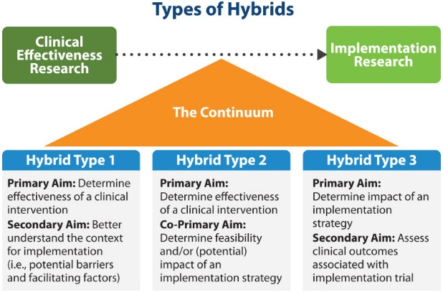  https://implementationscience.biomedcentral.com/articles/10.1186/s13012-022-01245-0  - Level of the intervention:  - Individual provider  - Team/unit  - Organization  - System
Outcomes | - What is the targeted change?  - How will you measure these changes?  - How likely is it that your initiative will achieve key study outcomes?  - What are some possible unintended consequences?  - Implementation (e.g. acceptability, adoption, feasibility, fidelity, sustainability) and/or health outcomes?
Stakeholder engagement | - Is there a clear engagement process for key stakeholders?  - Community advisory boards  - Local champions  - Local leadership  - Stakeholder perceptions of intervention characteristics  - Leadership engagement - commitment, involvement, and accountability of leaders and managers with the implementation.  - Characteristics of individuals  - Meaningful and sustainable partnerships  - Capacity building, bidirectional learning, resource sharing
Implementation Strategies | - Have you developed an implementation strategy? How will the initiative be delivered, adapted, adjusted?  - What are the key elements that must be delivered to be successful?  - To what extent will the key aspects of the program be delivered as intended?  - How will you assess program delivery?  - What adaptations or modifications do you think will be necessary to help implement the initiative to different settings?  - Possible implementation challenges to overcome?  - How will you know what adaptations or modifications were made during the program?  - Who can help you keep track of modifications/adjustments?  - What are some of the possible obstacles to consistent implementation?  - Are there competing projects or programs to consider?  - What cost and resources (including time, burden) need to be considered?  https://re-aim.org/applying-the-re-aim-framework/re-aim-guidance/use-when-planning-a-project/planning-tool/  https://sites.wustl.edu/wudandi/  https://cpb-us-w2.wpmucdn.com/sites.wustl.edu/dist/6/786/files/2017/11/DIRC-implementation-strategies-tool-1v33amk.pdf
Maintenance | Is this project sustainable within the institution/healthcare system? How will it be sustained?  At the setting level, the extent to which a program or policy becomes institutionalized or part of the routine organizational practices and policies.  What will happen long-term?  - What are likely implementation challenges that will need to be overcome?  - What infrastructure supports will be needed to sustain the initiative?  - Is there infrastructure or funding that will remain?  - How will this initiative align with current and future policies, programs and priorities?  - How will individuals be delivered the key components of the intervention over time?  - How will you track success and provide ongoing feedback?  https://www.re-aim.org/about/what-is-re-aim/maintenance/
STUDY CONDUCT
Identification of Barriers and Facilitators | How will you identify factors that affect implementation outcomes and tailor implementation strategies to overcome negative factors (barriers) and enhance positive factors (facilitators)  - Instruments for measuring barriers: Multiple-factor Assessment Instruments including combinations of innovation, provider, patient, organizational, & structural/community-level constructs; single factor assessments  - Instruments for measuring facilitators  https://cpb-us-w2.wpmucdn.com/sites.wustl.edu/dist/6/786/files/2017/08/DIRC-BarriersFacilitators_Toolkit-1gc9m0a.pdf
Feasibility & Contingency Plans | Do you have contingencies in place, should methods not work as planned?
Training | - Is there a training protocol in place for all stakeholders?  - Will stakeholders need booster sessions?  - How will you ensure consistent conduct?  - Do staff need training for data collection?
Data Recording and Reporting | - Where will data be collected?  - Can IT systems be leveraged for data collection?  - Will data be captured in parallel with routine clinical assessments?  - Will multiple data systems be utilized, requiring transfer and integration?  - Where will data be stored?  - Where and how will the data be used?
Safety Monitoring | - Patient Safety  - Traditional clinical outcomes, quality of care metrics, access to care  - Provider Impacts  - Workload/burden, burnout, role changes, team dynamics  - System Effects  - Resource allocation, workflow disruption, opportunity costs
Adverse Events (and Unintended Consequences) | - Resource diversion effects  - Equity impacts  - Systemic unintended consequences  - Implementation strategy burden  - Disuse of effective practices  - Misuse of evidence-based interventions
Statistical Analysis | - What data are critical to the statistical analysis plan (SAP)?  - Have you considered mediators and moderators of your outcomes?
DISSEMINATION
Dissemination Plan | - How will information be used?  - Plan for dissemination (participants, healthcare system, community, broader scientific community, leadership)  - What are likely modifications or adaptations that need to be made to implement in other settings?
Collaboration Plan | - Define and document roles  - Communication strategy  - Authorship  - Document/data sharing plans

